**QuoteBlock Module**

quote block list

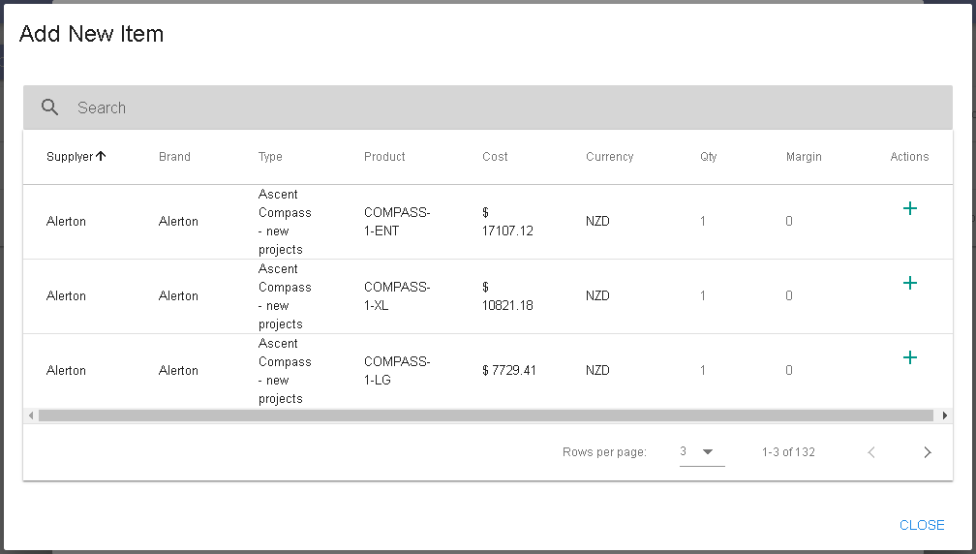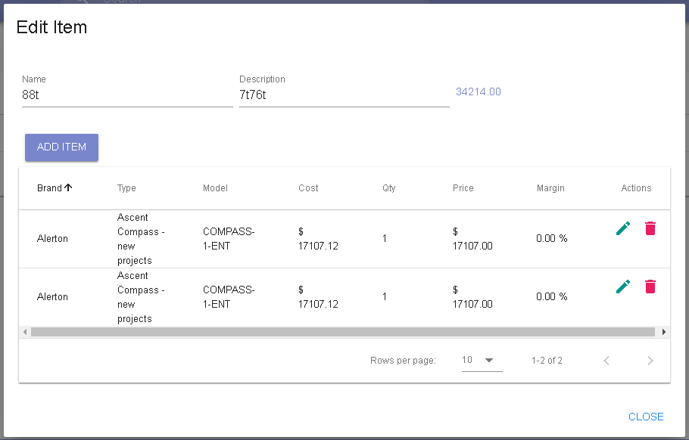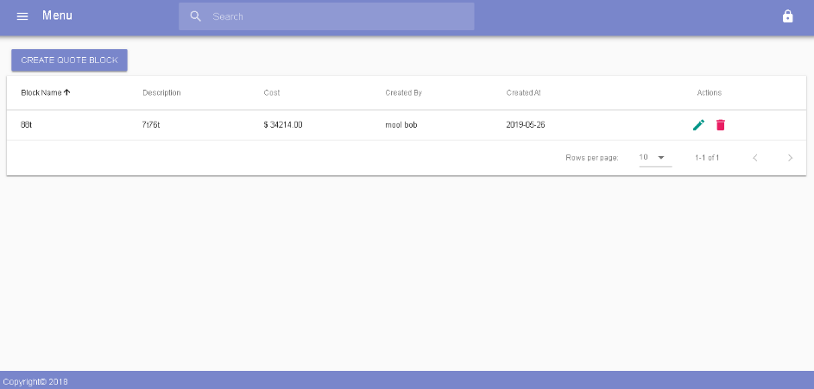

dialogPriceList

dialogQuoteBlock

db: QuoteBlock

db: PriceList

db: QuotePriceList